Create a workspace, warehouse and lakehouse

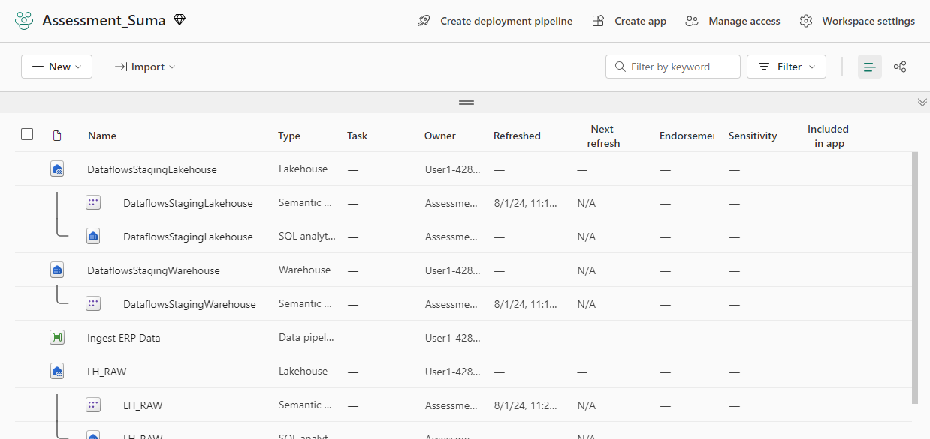

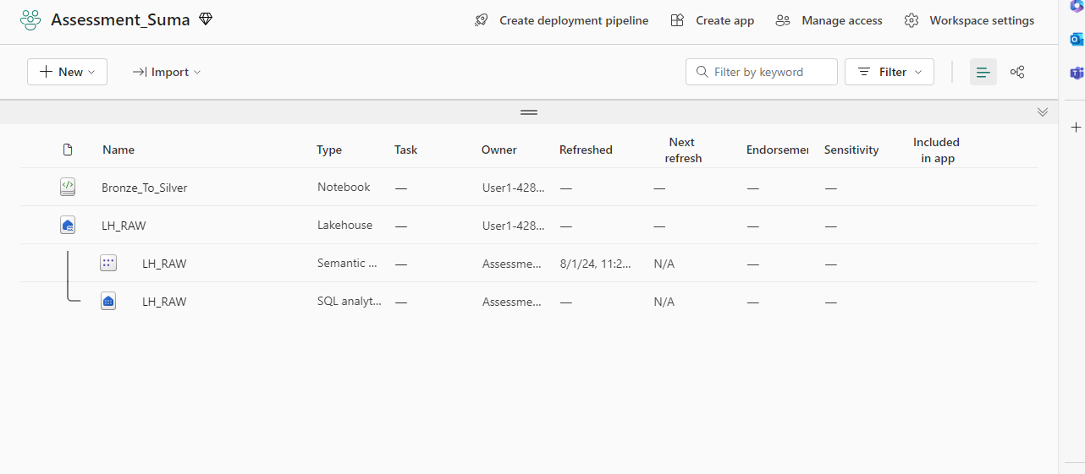

Load data into lakehouse through files

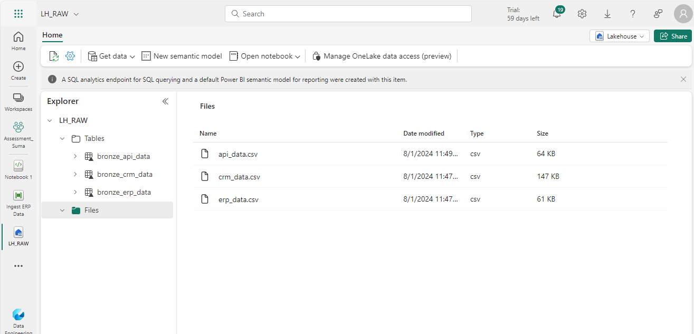

Load data to tables

Data cleaning using notebook

